**Davie-Lévis Community Liaison Committee — Call for Applications**

**Are you interested in the shipbuilding industry and looking to get involved in your community?**  
We’re looking for a resident from the **central sector** to join the Davie Liaison Committee. This is a unique opportunity to take part in discussions about the shipyard’s modernization projects and operations, while learning more about the industry.  
  
Not a resident of the central sector? If you’re interested, feel free to fill out the form anyway. To learn more about the Committee or to view the map of the Lévis sectors, visit [www.davie.ca/relations-communautaires/](http://www.davie.ca/relations-communautaires/).  
  
The Committee meets four times a year, on Tuesday evenings, at the shipyard.  
  
Contact: [ljbeaudoin@transfertconsult.ca](mailto:ljbeaudoin@transfertconsult.ca)

Required

1. What is your first and last name?



2. How well do you know Chantier Davie and the Lévis area?



3. Which sector do you live in?

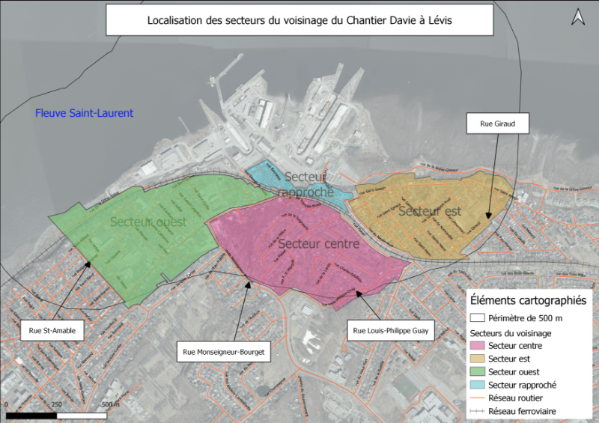

Eastern sector

Central sector

Nearby sector

Western sector

4. What is your connection to the company? Do you know anyone who works there, for example?



5. Could you share any professional experiences or specific skills that could be of value to the Committee?



6. Are you available on Tuesday evenings (four meetings per year: March, June, September, and December)?

Yes

No

I don’t know / to be confirmed

7. Leave us your email address and phone number so that we can contact you.



Send

Never share your password.

Report abuse